Lise Meitner Prize for Nuclear Science 2006

The European Physical Society awarded through its Nuclear Physics Board the Lise Meitner Prize for Nuclear Science 2006 to Professor David Brink (Emeritus Fellow, Balliol College, University of Oxford, UK) and Professor Heinz-Jürgen Kluge (Gesellschaft für Schwerionenforschung, Darmstadt, Germany). Medals, diplomas and cheques, sponsored by CANBERRA, France, were presented to the two Laureates at a special ceremony at the Seventh International Conference on Radioactive Nuclear Beams (RNB7) in Cortina d’Ampezzo, Italy, on July 7, 2006.

David Brink is honoured for his many contributions to the theory of nuclear structure and nuclear reactions which have helped to shape Nuclear Physics over several decades. He is one of a select band of theorists whose work over more than forty years has deeply influenced the field. His seminal work with D Vautherin in 1969-1971 on a theory of nuclear masses using effective interactions of the Skyrme type in a mean field approach proved particularly successful and established the ground rules for thousands of papers in nuclear theory. This work introduced density functional methods into nuclear many-body theory and has been cited over 1150 times, including 30 in 2003. His methods are currently being used by theorists all over the world in the new field of exotic nuclei.

Brink’s 1972 work on transfer reactions between heavy ions is also heavily cited by both theorists and experimentalists. Based on semi-classical ideas, this work provided a useful simple way of understanding and predicting important selection rules for transfer reactions.

Brink’s ideas and insights have also helped to clarify a variety of other phenomena including nuclear giant resonances, clustering in nuclei and quantum mechanical and semi-classical theories of heavy-ion scattering. With C V Sukumar and others he showed how the Feynman Path Integral approach to quantum effects could be applied successfully to nuclear reactions.

Brink’s work reflects his remarkable intuition, his clarity and ability to simplify the description of complicated phenomena by identifying the most appropriate approximations. He has had a large number of students and collaborators from all over the world. For all of them he has been a source of scientific and human inspiration and admiration. His commitment to the value of truth and his unselfish attitude to sharing knowledge have made him an outstanding figure in nuclear physics and one still very active at the frontline of research.

Heinz-Jürgen Kluge has enriched our knowledge of the masses, sizes, shapes and spins of nuclei through a number of decisive, sophisticated and brilliant experiments combining techniques of atomic and nuclear physics. He is honoured for his key contributions to these developments.

As a young post-doctoral researcher in the early 1970’s he set up an optical pumping experiment on a chain of neutron deficient mercury isotopes at ISOLDE, CERN, and measured their spins, moments and charge radii. Recently, backed by the huge progress in laser techniques and isotope production, he initiated a heroic experiment to measure the tiny shifts in the atomic spectra of Li-isotopes produced by the different nuclear volumes of the isotopes. The same technique was used successfully to measure the size of the very exotic halo nucleus ¹¹Li, so-called because of the way some of its neutrons are distributed far outside the protons. His application of laser spectroscopic trace analysis to the study of environmental ⁹⁰Sr after the Chernobyl disaster earned him the prestigious Helmholtz award in 1990.

Kluge’s development of the ISOL-trap for the precision mass measurement of nuclear masses is well known. His exploitation of this method has led to the readjustment of the nuclear mass scale over large regions of the nuclear chart far from stability, and his precise determination of beta decay properties led to fundamental tests of weak interaction theory. This method is now applied worldwide, often by Kluge’s pupils, or with their support. As head of the relevant GSI-group he has also pushed the complimentary Schottky mass measurements in the storage ring ESR.

Heinz-Jürgen Kluge’s experimental ideas and achievements have had an invaluable impact on the art of experimental atomic and nuclear physics, and his results for nuclear ground state properties have provided a reliable and indispensable cornerstone for nuclear theory. He has inspired at least 55 PhD students with his physics skill and enthusiasm, many of whom are active in science and academia.

Hartwig Freiesleben
Technische Universität Dresden
Chairman, Nuclear Physics Board

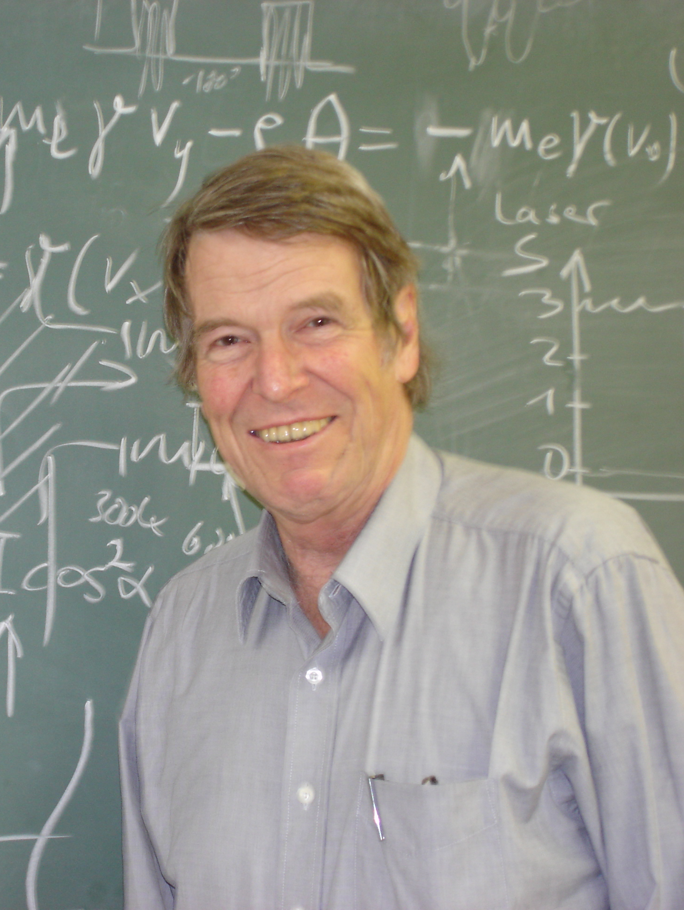
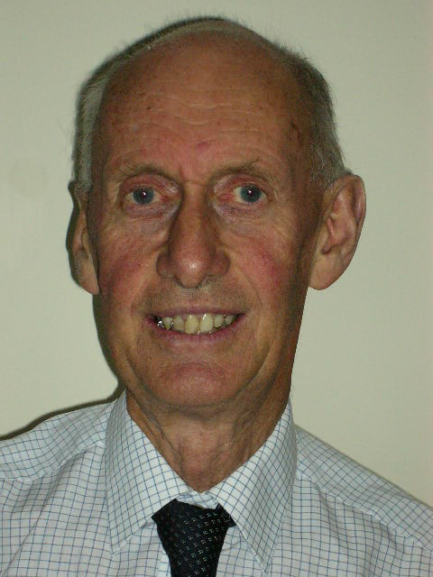

Professor David Brink Professor Heinz-Jürgen Kluge

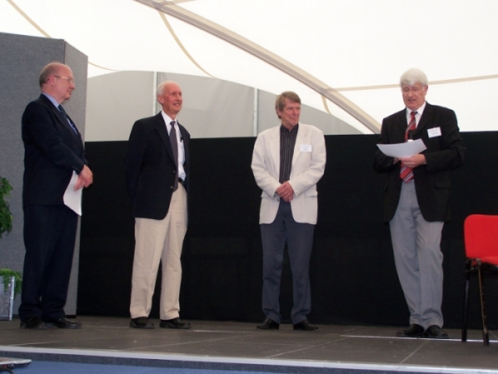

Lise Meitner Prize Ceremony
from left to right: Ron Johnson, David Brink, Heinz-Jürgen Kluge, Hartwig Freiesleben

